1. Create a folder named LotteryApp in c:\

2. Create a sub-folder named Files

Example: C:/LotteryApp/Files

3. Download the Participants.txt and Prizes.txt into C:/LotteryApp/Files

If you already have created the LottoApp in Eclipse then just replace the Main.java, Common.java and Validations.java with the most current classes.

**SQL (SQLite)**

SQLite download and Installation: <https://www.youtube.com/watch?v=wXEZZ2JT3-k>

Once SQLite is fully installed in your computer then complete the following steps:

1. Create a sub-folder named Database inside the LoterryApp Folder

Example C:/LotteryApp/Database

1. Download the JDBC file (sqlite-jdbc-3.34.0 ) and LotteryHist.db to C:/LotteryApp/Database.
2. The JDBC file is the driver that interacts between Java and SqlIte.

The Final LotterApp folder structure should look like this one below:

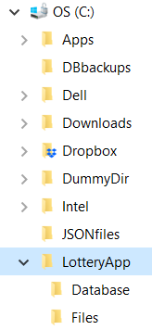

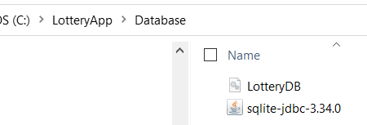

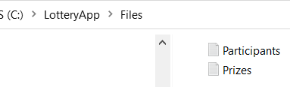

**How to include the JDBC driver (jar) to the Project in Eclipse:**

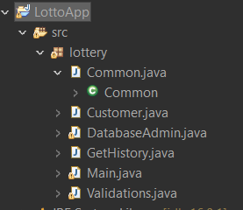

Go to the root LottoApp and do “right click”, **Select “Build Path**” then “**Configure Build Path**”

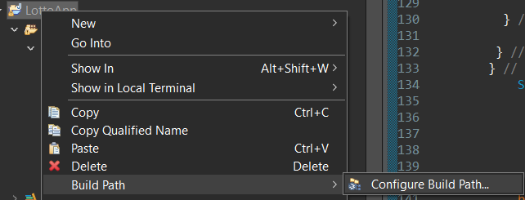

Next step is .. select Modulepath and Libraries option then click the buttom “Add External Jars”.

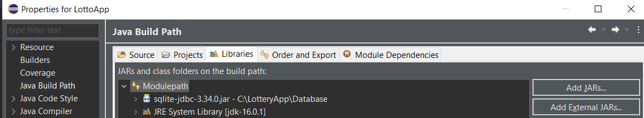

From your folder C:LotteryApp\Database … select the “sqlite-jdbc-3.34.0” file (Driver)

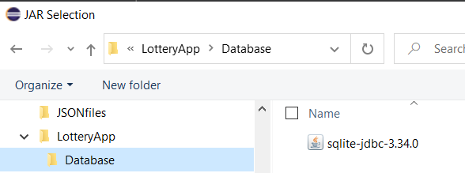

Then Make sure that the file was loaded and click on “Apply and Close”

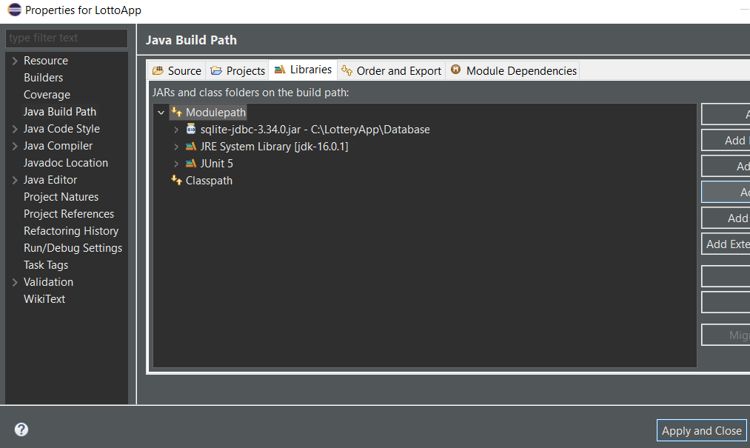

**LottApp Main Idea and Classes relationship**

SQL LotteryHist table

DatabaseAdmin Class

List of Winners

Number of Prizes?

Get winners randomly

Prizes.txt

Participants.txt

Common Class

Validations Class

Main.java